Git Setup & First Commit (Step-by-Step)
Goal: Configure Git locally with your GitHub identity, initialize a local repo, and make your first commit.
git config --global –list
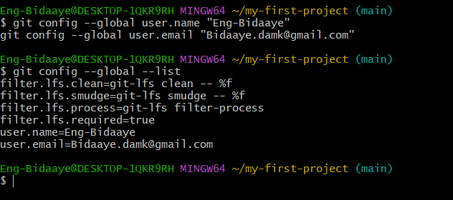
▶ Navigate to a workspace
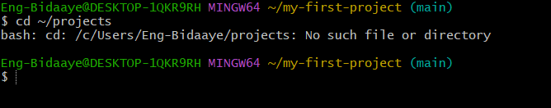
Create project folder
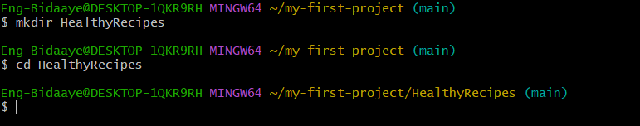
▶ Initialize Git
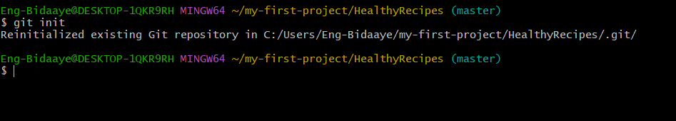

Verify repository
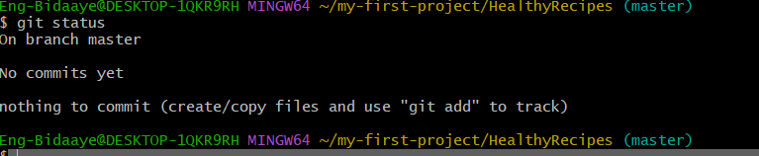
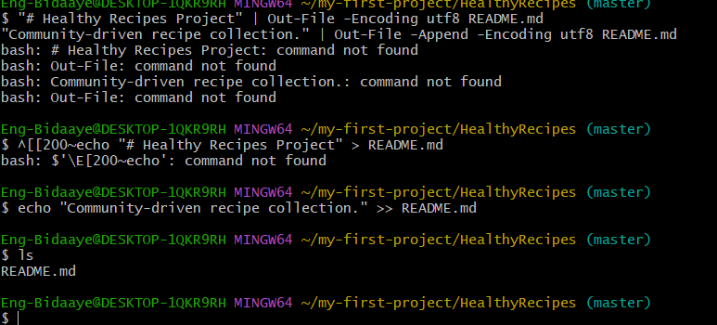

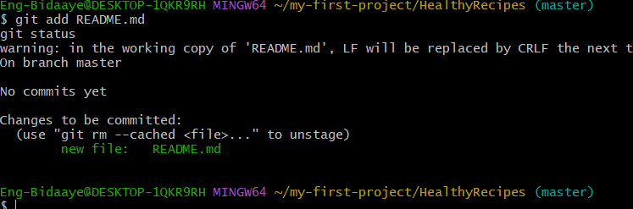
— Commit
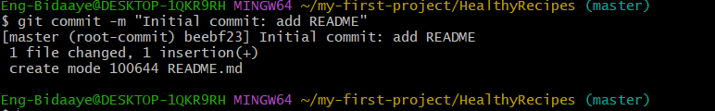
git log –oneline
